GAME IDEA 1: Game Design Brief
Concept:
Hide Me is simple stealth game where the player runs from drones trying to hunt them down. You lose the game when the drone hits the player, the player can see where the drones field of vision is and use certain areas to hide from drones as they pass
Gameplay:
the player is spawned in the centre of a maze and they are tasked with getting to one of 4 exits they must avoid the drones patrol patterns by using special areas that hide them from the drones. The game ends when the player reaches one of the exits. If the player is caught they have the option to ether restart the game or leave, this also displays how long you survived.
Core Mechanics:
safe areas need to work but be limited
movement needs to be the right pace
enemy need to only detect the player if they are in range
enemy vision range needs to be visible
the maze needs to be simple but not easy
Minor Mechanics/Logic:
first person point of view
more drones appear the longer it takes for the player to finish
2 variations of the maze should swap back and forth when game is finished but not on restart
Out of scope mechanics:
a randomised maze
an elite drone that hunts you down directly
teleportation doorways
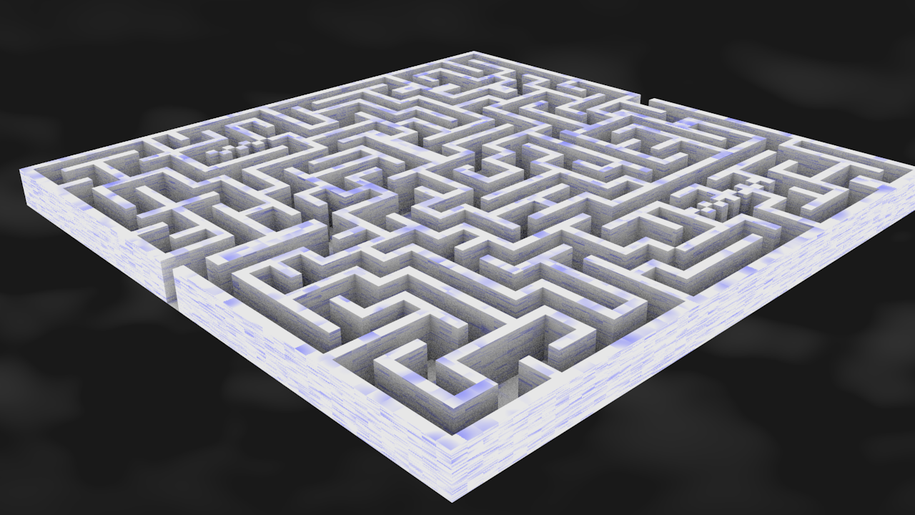
Inspirations/similar works:
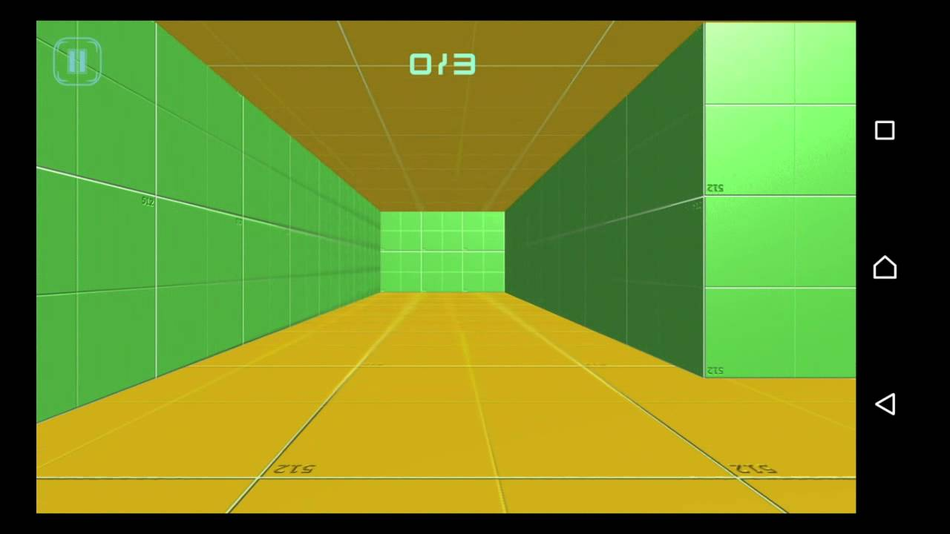

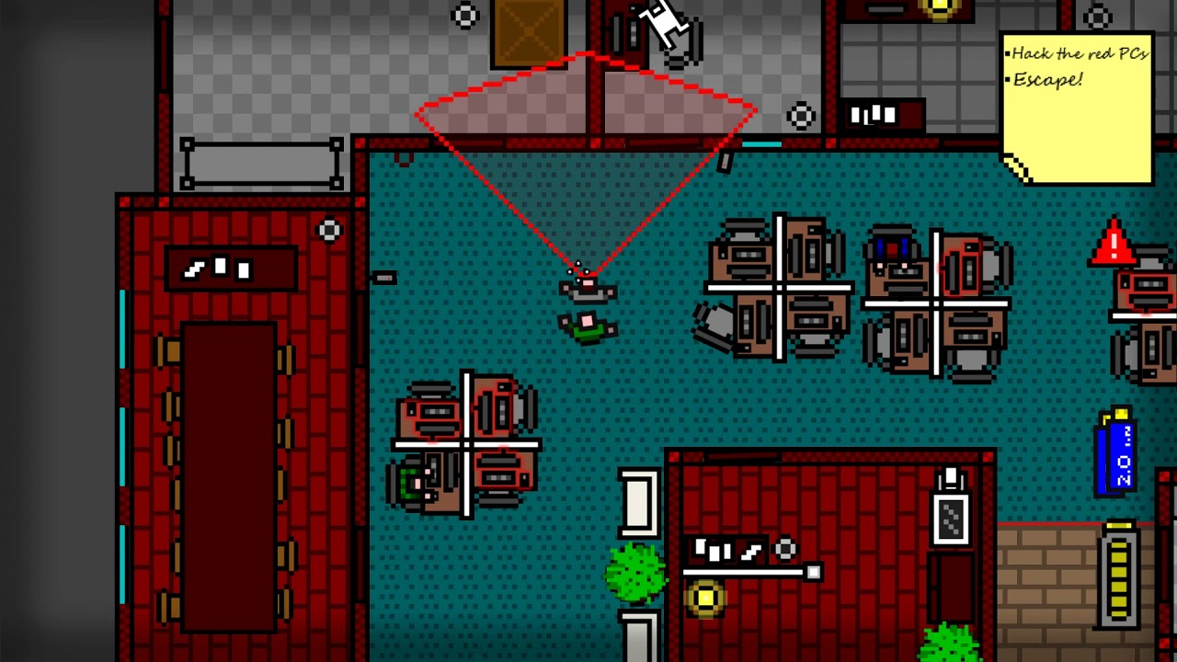
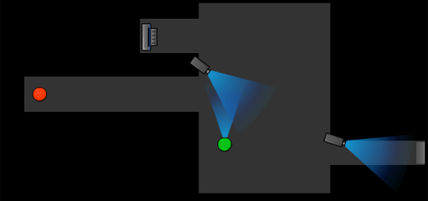

Development challenges:
im really worried about the enemy detection system and how it interacts with the safe zone and walls, another problem is the EFOV being visible to the player

